Supporting Information
Experimental and modeling study of the pyrolysis and combustion of dimethoxymethane
Florence H. Vermeireª, Hans-Heinrich Carstensenª, Olivier Herbinet^{b}, Frédérique Battin-Leclerc^{b}, Guy B. Marinª, Kevin M. Van Geem^{a,}*
ªLaboratory for Chemical Technology, Ghent University, Technologiepark 914, 9052 Gent, Belgium
^{b}Laboratoire Réactions et Génie des Procédés, CNRS, Université de Lorraine, Nancy, France
*Corresponding author: Technologiepark 914, 9052 Gent, Belgium, fax: +32 92645824, e- mail: kevin.vangeem@ugent.be

Table of contents

1. Experimental results 3
2. Microkinetic model 4
3. Potential energy surface for the methoxymethoxymethyl and dimethoxymethyl radicals 5
4. Model performance for experimental data sets found in the literature 6
4.1 Dimethoxymethane oxidation in a plug flow reactor 6
4.2 Dimethoxymethane oxidation in a jet-stirred reactor 8
4.3 Lean and rich premixed DMM flames 9
5. Model performance for kinetic models found in literature 12
6. Model performance with the Burke propene mechanism 14
7. Comparison with low-temperature reactivity of dimethyl ether 15
9. Sensitivity analyses 18
9.1 Low-temperature oxidation - 700 K 18
9.2 High temperature oxidation - 900 K 19
10. Results of quantum mechanical calculations 20
10.1 Thermodynamic properties calculated at the CBS-QB3 level of theory 20
10.2 Modified Arrhenius parameters calculated at the CBS-QB3 level of theory 23
11. References 26

Experimental results
The experimental data acquired for the pyrolysis and oxidation of dimethoxymethane in the jet-stirred reactor, located in Nancy, France, is provided as a separate Excel spreadsheet.

Kinetic model
The kinetic model in CHEMKIN format developed for the pyrolysis and oxidation of dimethoxymethane is provided as a separate text file.

Potential energy surface for the methoxymethoxymethyl and dimethoxymethyl radicals
The potential energy surface for the two radicals formed from dimethoxymethane is given in Figure S 1. The two radicals that are formed are the methoxymethoxymethyl radical, labeled as R₁ in Figure S 1, and the dimethoxymethyl radical, labeled as R₂ in Figure S 1. The methoxymethoxylmethyl radical can react via a β-scission reaction with the formation of a methoxymethyl radical and formaldehyde. The barrier for this reaction is 102 kJ mol⁻¹. The methoxymethyl radical can form a methyl radical and formaldehyde by a subsequent β-scission reaction with a slight higher barrier of 108 kJ mol⁻¹. The methoxymethoxymethyl radical can alternatively isomerize into the dimethoxymethyl radical. The barrier for this reaction (160 kJ mol⁻¹) is substantially higher compared to the one for the β-scission reaction. The dimethoxymethyl radical can form methyl formate and a methyl radical after a β-scission reaction. The barrier for this reaction is rather low (61 kJ mol⁻¹).
All radicals shown in Figure S 1 can also react with molecular oxygen. It can be expected that the addition of molecular oxygen to the dimethoxymethyl radical will be difficult, due to the low barrier for the β-scission reaction and hence the short life time of this radical.

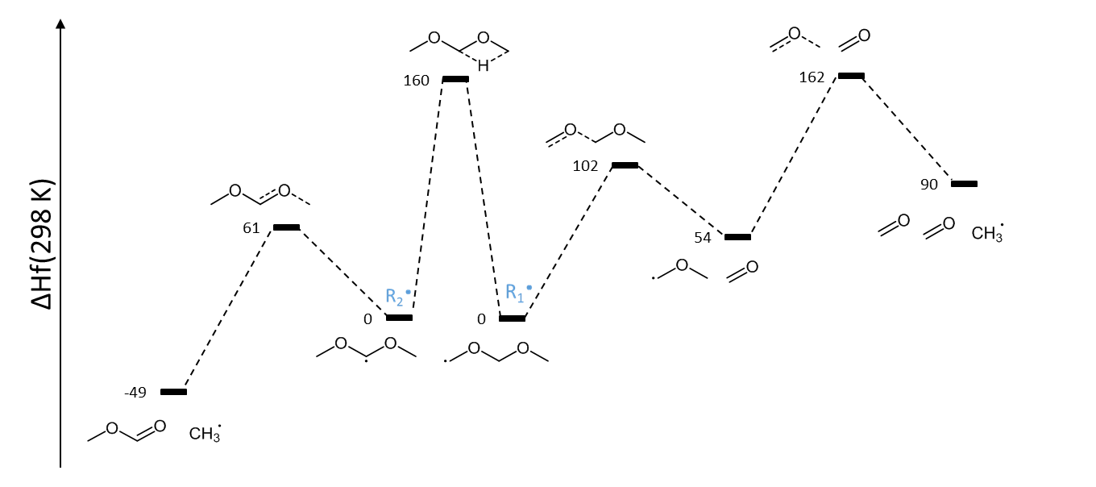
Figure S 1. Relevant part of the potential energy surface for the methoxymethoxymethyl and dimethoxymethyl radical. The values are enthalpies of formation in kJ mol⁻¹ calculated at the CBS-QB3 level of theory at 298 K relative to R₁.

Model performance for experimental data sets found in the literature

Dimethoxymethane oxidation in a plug flow reactor
The microkinetic model has been validated with experiments that were reported by Marrodàn et al. [1]. These experiments are performed in an isothermal plug flow reactor. A large range of pressures from 20 to 60 bar have been investigated. The air excess ratio was varied from λ=0.7 to λ=20. Simulations with the microkinetic model have been performed with the plug flow reactor of CHEMKIN [2]. Results of the model simulations are presented in Figure S 2, Figure S 3 and Figure S 4.
A qualitative and quantitative good model performance is present for most species and most experimental conditions. Similar to the model performance of the reported jet-stirred reactor experiments, the mole fractions of methane are over predicted. For the plug flow experimental conditions, also an under prediction of the formaldehyde mole fraction is present. As discussed during the sensitivity analysis in paragraph 9.2 the hydrocarbon mole fractions are very sensitive to the reaction of methyl radicals with hydroperoxy radicals. The methoxy radical formed in this reaction decomposes with the formation of formaldehyde. A re-evaluation of this reaction at higher pressures may improve model predictions for both hydrocarbon and formaldehyde mole fractions.
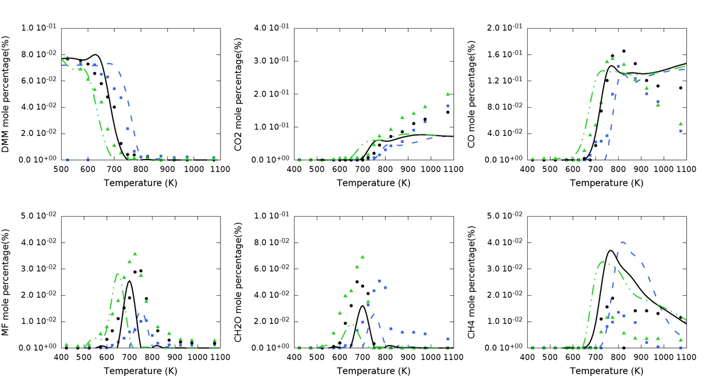
Figure S 2. Species mole fractions as a function of temperature for the oxidation of DMM. Experiments (dots), reported by Marrodàn et al. [1], and simulation results (lines) are compared for a pressure equal to 20 bar (blue), 40 bar (black) and 60 bar (green). The air excess ratio is λ=0.7. Simulations are done with the plug flow reactor option of CHEMKIN software and the new kinetic model.
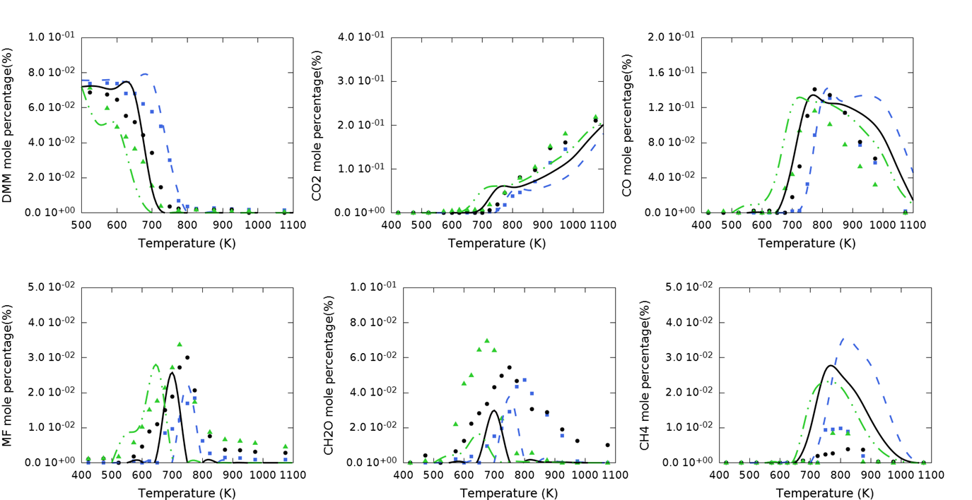
Figure S 3. Species mole fractions as a function of temperature for the oxidation of DMM. Experiments (dots), reported by Marrodàn et al. [1], and simulation results (lines) are compared for a pressure equal to 20 bar (blue), 40 bar (black) and 60 bar (green). The air excess ratio is λ=1.0. Simulations are done with the plug flow reactor option of CHEMKIN software and the new kinetic model.
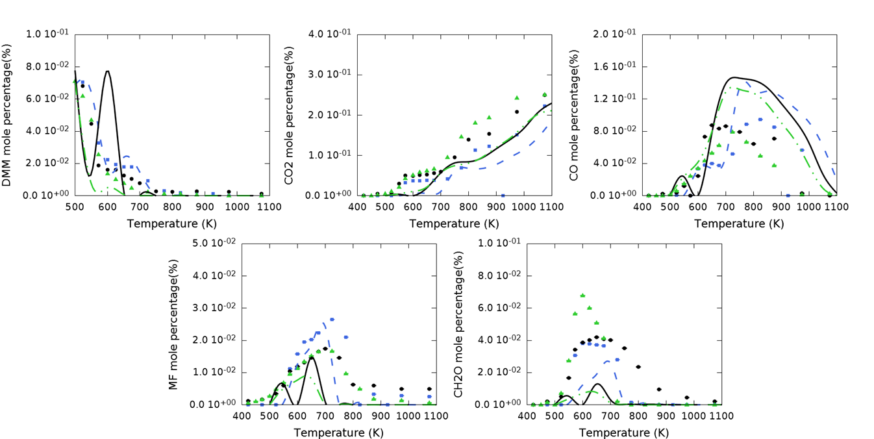
Figure S 4. Species mole fractions as a function of temperature for the oxidation of DMM. Experiments (dots), reported by Marrodàn et al. [1], and simulation results (lines) are compared for a pressure equal to 20 bar (blue), 40 bar (black) and 60 bar (green). The air excess ratio is λ=20. Simulations are done with the plug flow reactor option of CHEMKIN software and the new kinetic model.

Dimethoxymethane oxidation in a jet-stirred reactor
The experimental dataset of Daly et al. [3] has also been used for validation. The operating conditions for those experiments are very similar to the operating conditions for the experimental dataset discussed in this manuscript. The results are presented in Figure S 5. The predicted DMM conversion as function of temperature differs strongly from the data. For this reason and to be able to make a meaningful comparison with experimental product profiles, the species mole fractions are plotted as a function of DMM conversion. The reported experimental DMM mole fraction at 800K is less than the initial mole fraction of DMM, which is 0.015. This indicates that the experimental conversion starts at a temperature lower than 800 K. The simulated conversion, however, starts at a temperature of 900 K. Daly et al. postulated that surface-catalyzed reactions may be occurring. Two reactions are proposed, i.e. the catalytic conversion of DMM to (1) formaldehyde and dimethyl ether and (2) methanol and acetaldehyde. The appearance of catalytic reactions can explain why the DMM mole fraction is over predicted by the kinetic model, as well as the under prediction of both formaldehyde and methanol. Furthermore, it can be noticed that the methane, ethane and ethene mole fractions are over predicted by the kinetic model, similar to observations with the other experimental datasets.
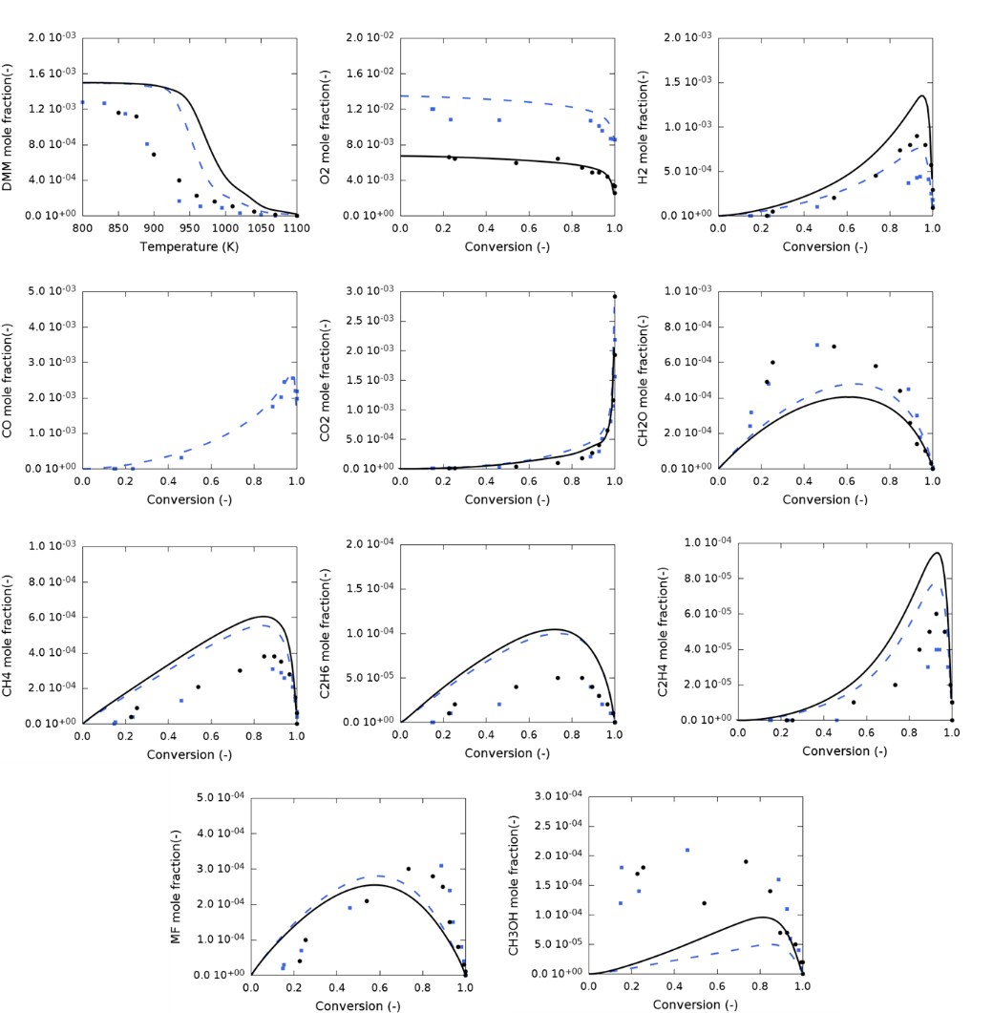
Figure S 5. Species mole fractions as a function of temperature for the oxidation of DMM. Experiments (dots), reported by Daly et al. [3], and simulation results (lines) are compared for a pressure equal to 5 bar. The equivalence ratio is ϕ=0.444 (blue dashed lines and squares) and ϕ=0.889 (black full lines and dots). Simulations are done with the continuously stirred reactor option of CHEMKIN software and the new kinetic model.

Lean and rich premixed DMM flames
The experimental datasets for lean and rich premixed flames reported by Dias et al. [4] have been used for validation. The experimental data is acquired at 50 mbar, pressures much lower compared to the pressures used in this work, and at temperatures typically used for flames, i.e. temperatures much higher compared to the ones in this work. Because of the very different operating conditions and different system, i.e. premixed flames instead of jet-stirred reactor, this dataset is ideal to demonstrate the wide range of applicability of the developed kinetic model. The kinetic model and transport data are implemented in CHEMKIN using the model for premixed burners. A comparison between simulations and experimental values are given in Figure S 6 for the lean flame and Figure S 7 for the rich flame. Considering that this kinetic model is not developed to do flame simulations, most species mole fractions are well predicted. The main discrepancies for the lean flame are in the H₂ and hydroxyl and methoxy radicals mole fractions close to the burner. For the rich flame, the hydrocarbon mole fractions are over predicted, similar to the observation made for the experiments reported in this work and the other literature experiments that are used for validation. Interesting is the clear under prediction of the methoxy radical mole fraction. The under prediction is present for both lean and rich flames at the same distance from the burner as the under prediction of hydroxyl radicals and the over prediction of hydrocarbon mole fractions. In the main text, analyses of the kinetic model indicate that a re-evaluation of the base mechanism could potentially improve the prediction of the hydrocarbon mole fractions. The reactions between methyl radicals and hydroperoxyl radicals are identified as very sensitive towards these mole fractions. Methyl and hydroperoxyl radicals could react with the formation of (1) methane and molecular oxygen or (2) methoxy and hydroxyl radicals. Re-evaluation of this branching ratio can simultaneously improve the methane, and other hydrocarbon species, mole fractions as well as the hydroxyl and methoxy mole fractions.
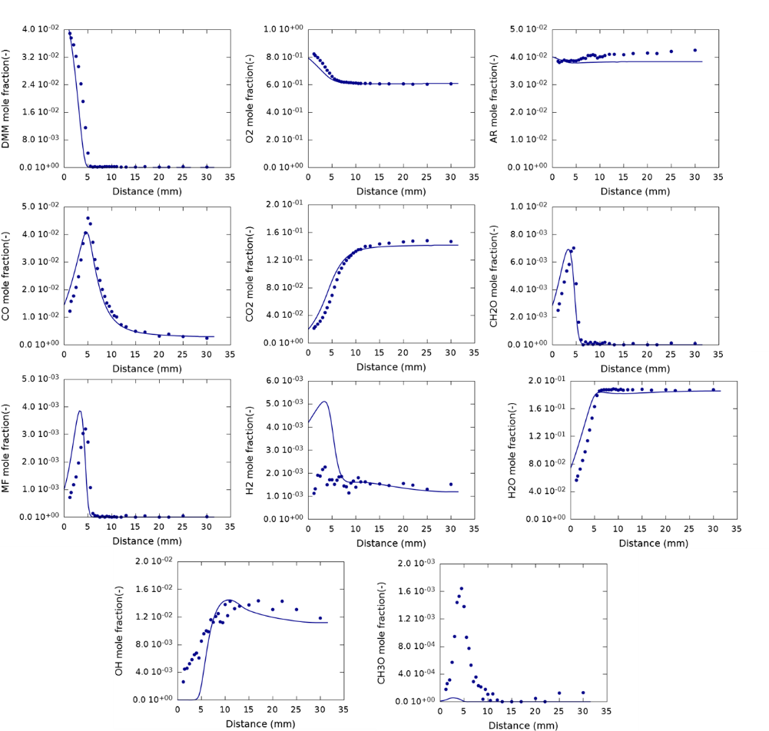
Figure S 6. Species mole fractions as a function of the distance from the burner for a lean premixed DMM flame with ϕ=0.24 and V₀=37.22 cm s⁻¹. Experiments (dots), reported by Dias et al. [4], and simulation results (lines) are compared for a pressure equal to 50 mbar. Simulations are done with the premixed burner option of CHEMKIN software and the new kinetic model.
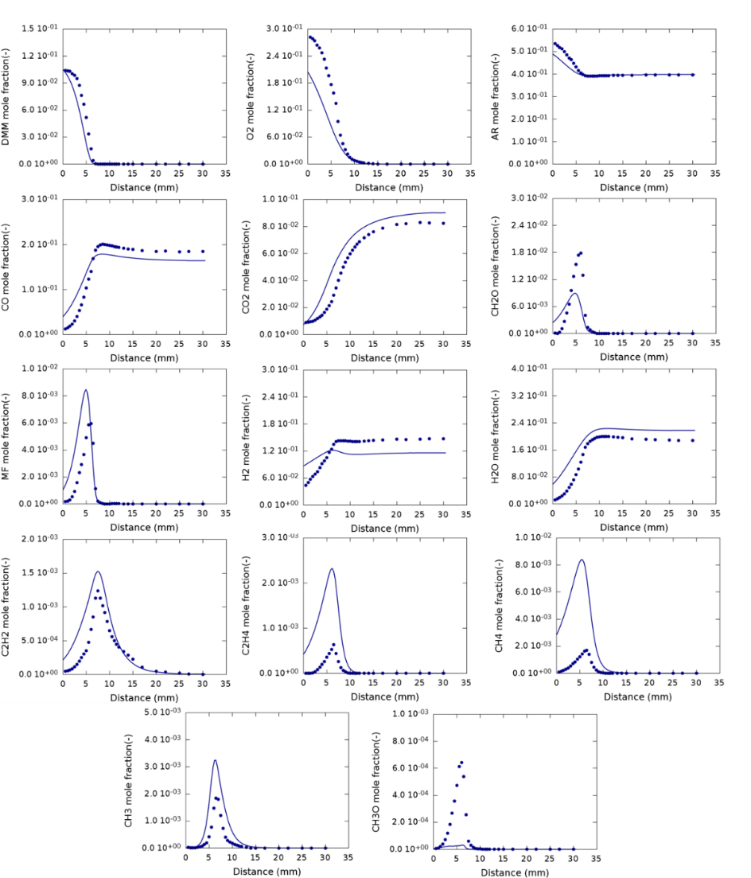
Figure S 7. Species mole fractions as a function of the distance from the burner for a rich premixed DMM flame with ϕ=1.72 and V0=33.33 cm s⁻¹. Experiments (dots), reported by Dias et al. [4], and simulation results (lines) are compared for a pressure equal to 50 mbar. Simulations are done with the premixed burner option of CHEMKIN software and the new kinetic model.

Model performance for kinetic models found in literature
The kinetic model developed by Marrodàn et al. [5] for a flow reactor at elevated pressures has been used to model the experimental data acquired in this work. The results are given in Figure S 8 for all equivalence ratios. In case of pyrolysis, the kinetic model does not properly describe the DMM conversion and consequently the product species mole fractions. The agreement between simulated and experimental results for oxidation is reasonable, but worsens for lower equivalence ratios. The mole fraction of some species, like CO and CO₂ are well predicted for ϕ=1.0 and ϕ=2.0, however discrepancies are present for other oxygenated species like DMM, formaldehyde, methanol and methyl formate.
Contrary to the simulations with the kinetic model developed in this work, the mole fractions of hydrocarbon species such as methane, ethane and ethene are well predicted for ϕ=2.0 and under predicted for ϕ=1.0 and ϕ=0.25. The reactions identified as sensitive for the prediction of these hydrocarbon species are the reactions between methyl radicals and hydroperoxy radicals. In the kinetic model developed by Marrodàn et al., the reaction between these species with the formation of methane and molecular oxygen is not present. The competitive reaction with the formation of methoxy and hydroxyl radicals has a fixed rate coefficient equal to 6.8 10¹² cm³ mol⁻¹ s⁻¹ at all temperatures. The difference in the presence of these reactions and their rate coefficients and the different prediction of the hydrocarbon mole fractions with both kinetic models is an additional indication that the over prediction of hydrocarbon species with the newly developed kinetic model might be related to the base mechanism.
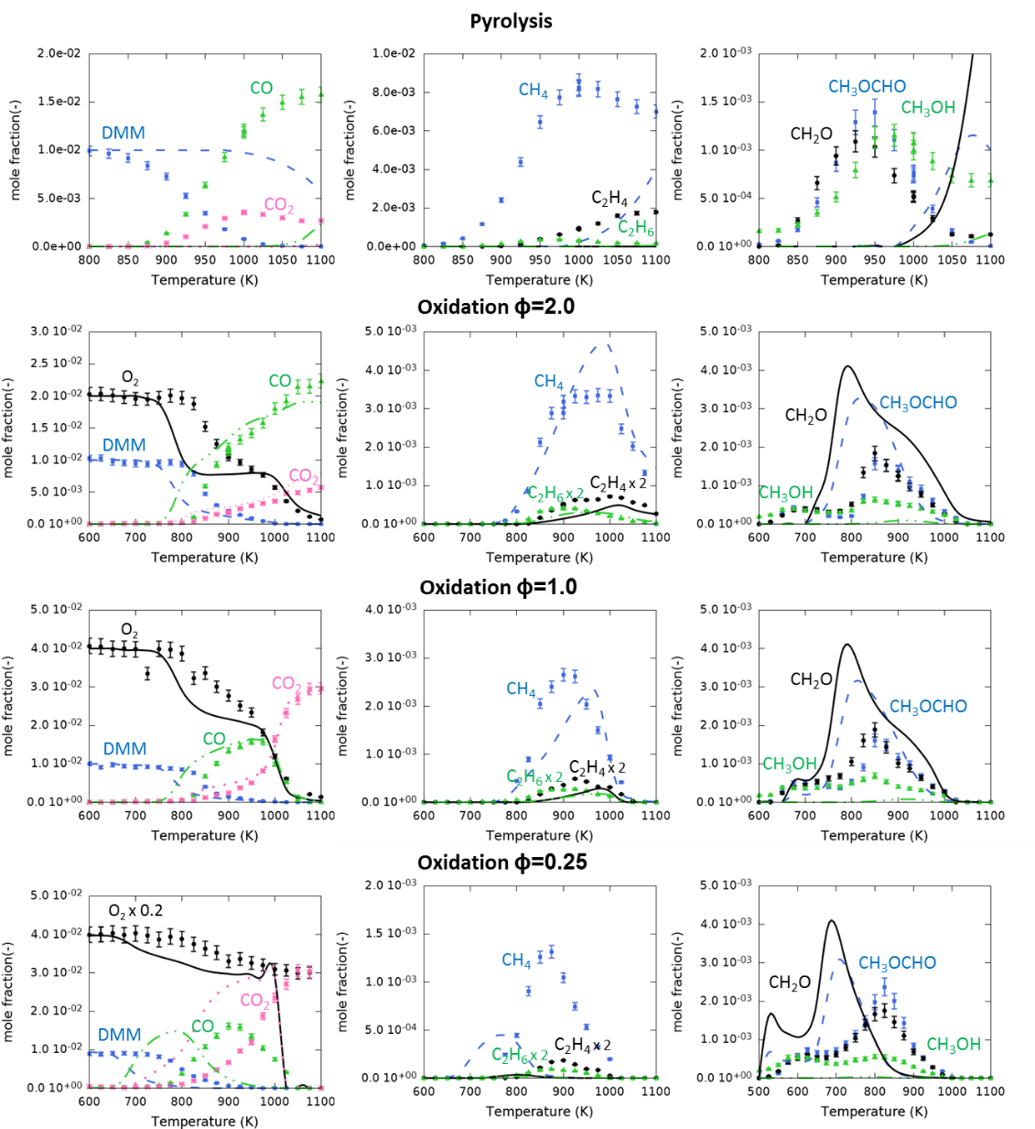
Figure S 8. Species mole fractions as a function of temperature for the pyrolysis and oxidation of DMM. Experiments from this work (symbols) and simulation results with the kinetic model of Marrodàn et al. [5] (lines) are compared. Experimental conditions are 1.07 bar, 2.83 s residence time, equivalence ratio of ∞, 2.0, 1.0 and 0.25 and inlet mole fraction of DMM 0.01. Simulations are performed with CHEMKIN software using the continuous stirred-tank reactor option. Mole fractions of some species are multiplied by a factor that is indicated on the figure.

Model performance with the Burke propene mechanism
The model performance for the pyrolysis of dimethoxymethane is tested with the use of 2 base mechanisms, i.e. the one developed by Metcalfe et al. [6] and the one developed by Burke et al. [7]. In Figure S 9 the experimentally acquired data is compared to simulations done with kinetic models that implement either one of the base mechanisms considered. The mole fractions of CO₂ and methyl formate are clearly over-predicted by the model that contains the base mechanism developed by Burke et al. [7], while no methanol formation is observed. The model performance of the kinetic model with the base mechanism developed by Metcalfe et al. [6] performs well for all product species mole fraction.
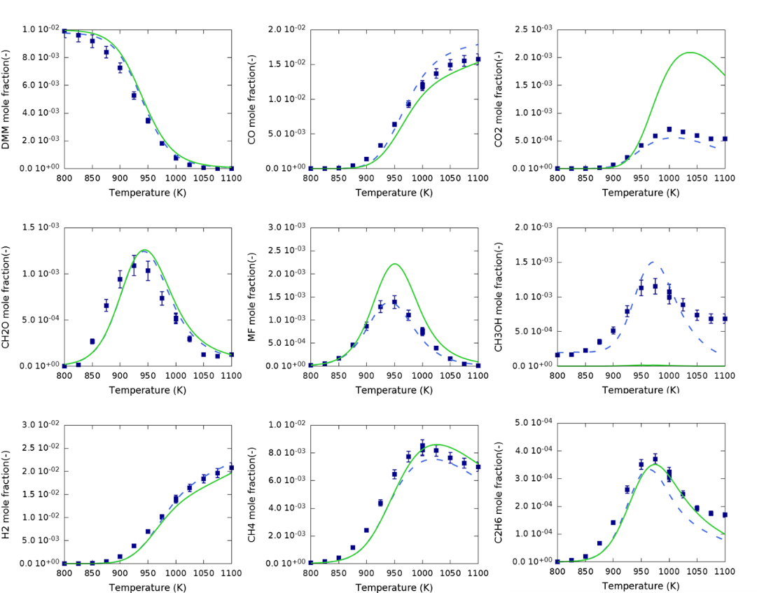
Figure S 9. Species mole fractions as a function of temperature for the pyrolysis of DMM. Experiments (dots) and simulation results (lines) are compared. Simulations are done with the new kinetic model that implements the base mechanism developed by Metcalfe et al. [6] (blue lines, dashed) or the base mechanism developed by Burke et al. [7] (green lines, full). Experimental conditions are pyrolysis, 1.07 bar, 2.83 s residence time, inlet mole fraction of DMM 0.01. Simulations are performed with CHEMKIN software using the continuous stirred-tank reactor option.

Comparison with low-temperature reactivity of dimethyl ether
Previous studies on the low-temperature oxidation of dimethyl ether (DME) [8] observed a high reactivity at low-temperature oxidation conditions. Because of structural similarities, the same amount of low-temperature reactivity was expected for the oxidation of DMM. However, as can be noticed in the mole fraction profiles of DMM in Fig. 6 to 8 in the main text, the low-temperature reactivity of DMM is very limited. To provide an explanation for this observation using rate of production analysis, the new kinetic model first needs to be validated against DME data. For this purpose, the experimental data for the DME oxidation published by Rodriguez et al. [8] are utilized. Because of the importance of the methoxymethyl radical during the oxidation of DMM, most thermodynamic properties and kinetics for the oxidation of DME are already incorporated in the microkinetic model. Only hydrogen abstraction reactions need to be added. For hydrogen abstraction reactions from DME by hydrogen atoms, molecular oxygen and hydroxyl, hydroperoxy, methyl and methoxy radicals, the rate expressions for DMM yielding the primary radical were adopted. A comparison of the model predictions with the experimental data is given in Figure S 10. Overall an acceptable agreement between the simulated results and the experimental data is obtained even though there is clear room for improvement. Most importantly for the purpose of this work, the low-temperature reactivity of DME is well reproduced by the kinetic model. At the same time, the peak heights of the hydrocarbon mole fractions are over-predicted while the mole fractions of formaldehyde, water and hydrogen peroxide are under-predicted.
Figure S 10 Species mole fractions as a function of temperature for the oxidation of DME. Experiments (dots), reported by Rodriguez et al. [8], and simulation results (lines) are compared. Experimental conditions are 1.07 bar, 2.0 s residence time, inlet mole fraction of DME 0.02 and equivalence ratio of 0.25 (blue), 1.0 (black) and 2.0 (green). Simulations are performed with the continuous stirred-tank reactor option of CHEMKIN software and the new kinetic model.
Fig 9. In the main text, which has already been discussed with respect to DMM oxidation also applies to DME oxidation. A rate of production analysis has been done for the oxidation of DME at stoichiometric conditions and 650 K. The results are compared to the rate of production analysis for the oxidation of DMM at the same conditions in Figure S 11. DME is, at these conditions, completely consumed via hydrogen abstraction reactions, hence yielding 100% methoxymethyl radicals. The main difference between DME and DMM is that at stoichiometric conditions and 650 K, the chain-branching pathway via Q₃OOH contributes to only 2% of DMM conversion but 23% of DME conversion. Note that this chain-branching pathway yields two reactive hydroxyl radicals and one less-reactive formyl radical. The second chain-branching pathway available for DMM oxidation, which contributes to 10% of its conversion, yields only one reactive hydroxyl radical next to a methyl (which loses its reactivity after adding to O₂) and a formyl radical. To conclude, during the oxidation of DME, only one pathway leads to chain branching, while two pathways lead to chain branching during the oxidation of DMM. However, these pathways account for 23% of the converted DME, while they account for only 12% of the converted DMM. Furthermore, the chain-branching pathway active in DME yields directly two reactive hydroxyl radicals, which is not the case for the major chain-branching pathway in DMM. Both the higher fraction of DME leading to chain branching and the direct formation of two hydroxyl radicals, explain the higher low-temperature reactivity of DME compared to DMM. The higher low-temperature reactivity of DME suggests that this pure compound has a lower auto-ignition temperature and hence a higher cetane number compared to DMM. However, when these compounds are used as additives mixed with diesel, the effect of the difference in low-temperature reactivity will be limited. For example, Vertin et al. [9] studied the cetane number of DMM and DMM-diesel mixtures. It was concluded that the low low-temperature reactivity and hence low cetane number of DMM does not reduce the cetane number of the blend until the level in the blend exceeds 30 vol%.
Figure S 11. Rate of production analysis to reveal important pathways during low-temperature oxidation of dimethyl ether. Rate of productions relative to the consumption of dimethyl ether (red, underlined) and dimethoxymethane (blue, italic) at 650 K are presented at stoichiometric conditions. The chain branching pathways are indicated in blue for dimethoxymethane and in red for dimethyl ether. Common chain branching pathways are hence highlighted in purple.

Sensitivity analyses

Low-temperature oxidation - 700 K
A sensitivity analysis has been performed at 700 K and an equivalence ratio equal to 1.0. Normalized sensitivity coefficients for the mole fractions of the main species formed during low-temperature oxidation have been calculated and are presented in Figure S 12. The most sensitive reactions that are present in the base mechanism [10] and responsible for the low-temperature reactivity are selected for the sensitivity analysis. The low-temperature reactivity is enhanced by the reaction of methyl radicals with hydroperoxy radicals to form the reactive hydroxyl and the methoxyl radical. Also important for the low-temperature reactivity are reactions starting from methylperoxy radicals. Hydrogen abstraction by this radical forms methylhydroperoxide, which leads to chain branching after scission of the hydroperoxy group and enhances the low-temperature reactivity. Reactions starting from methylperoxy radicals that do not lead to the formation of methylhydroperoxide lower the low-temperature reactivity.
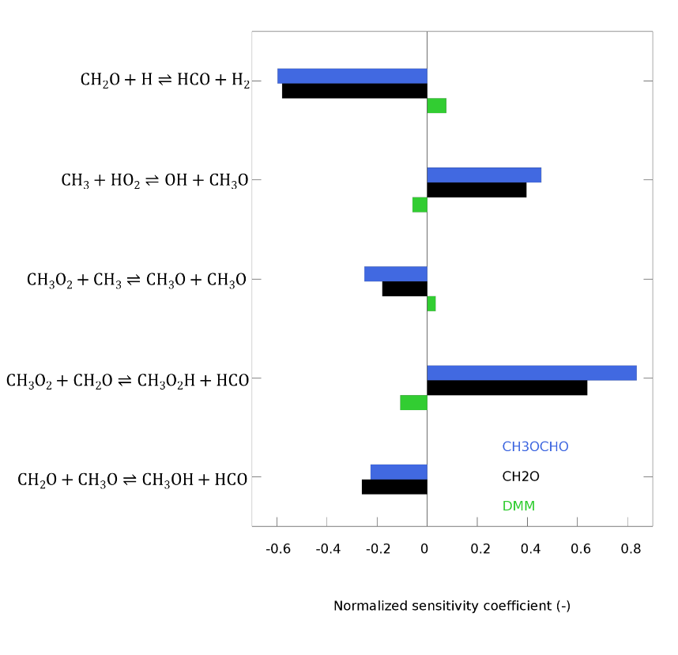
Figure S 12. Normalized sensitivity coefficients for the mole fractions of methyl formate, formaldehyde and dimethoxymethane at 700 K and equivalence ratio equal to 1.0 to indicate the importance of the base mechanism for the low-temperature reactivity

High temperature oxidation - 900 K
Too high mole fractions for hydrocarbon species are predicted by the microkinetic model for the oxidation of DMM. The mole fraction of the hydrocarbon species and methyl radicals are sensitive to various reactions that are present in the base mechanism [10] used during the development of the microkinetic model. A sensitivity analysis for the most sensitive reactions in the base mechanism has been performed and the normalized sensitivity coefficients are reported in Figure S 13.
Many reactions that have a positive sensitivity coefficient for the mole fractions of ethane and ethene have a negative sensitivity coefficient for methane and vice versa. Methyl radicals react mainly by hydrogen abstraction reactions with the formation of methane or by self-recombination with the formation of ethane. One reaction that has negative sensitivity coefficients for all hydrocarbon species is the reaction of methyl radicals with hydroperoxy radicals to form methoxy and hydroxyl radicals. The potential energy surface of the reaction of methyl radicals with hydroperoxy radicals has been calculated by Jasper et al. [11]. The modified Arrhenius parameters reported by Jasper et al. [11] are the ones used in the base mechanism [10].
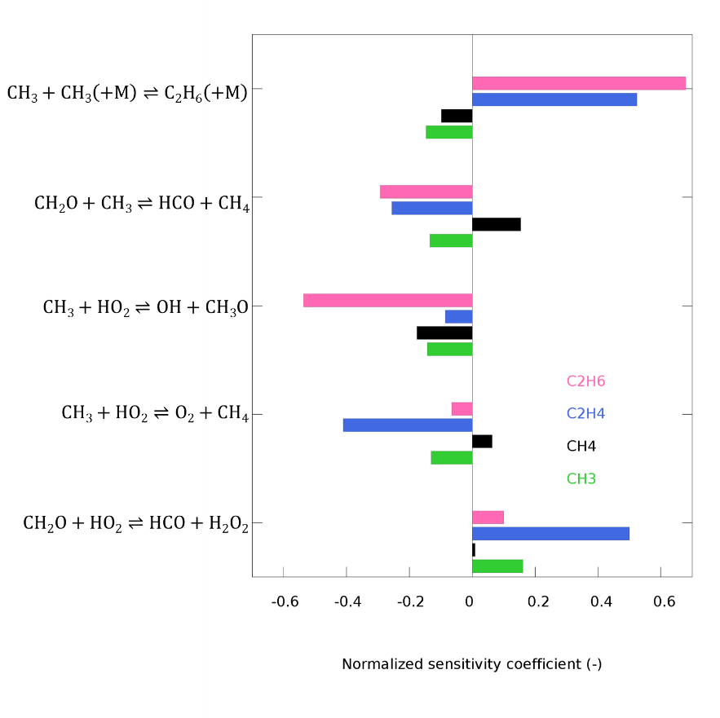
Figure S 13. Normalized sensitivity coefficients for the mole fractions of the main hydrocarbon species detected during the oxidation of DMM at 900 K and equivalence ratio equal to 1.0.

Results of quantum mechanical calculations

Thermodynamic properties calculated at the CBS-QB3 level of theory
Table S 1. Thermodynamic properties for important species during the pyrolysis and oxidation of dimethoxymethane determined with quantum mechanical methods at the CBS-QB3 level of theory
Species | ΔH_{f}° (298 K)  [kJ mol⁻¹] | S°(298 K)  [J mol⁻¹ K⁻¹] | Cp (500 K)  [J mol⁻¹ K⁻¹] | Cp (600 K)  [J mol⁻¹ K⁻¹] | Cp(800 K)  [J mol⁻¹ K⁻¹] | Cp(1000 K)  [J mol⁻¹ K⁻¹]
 | -345.97 | 351.86 | 156.56 | 173.63 | 198.39 | 217.20
 | -152.87 | 358.28 | 151.87 | 165.57 | 186.41 | 202.33
 | -152.77 | 371.67 | 138.69 | 152.61 | 176.23 | 194.70
 | -293.59 | 412.63 | 182.57 | 200.20 | 226.48 | 245.35
 | -309.89 | 417.92 | 178.04 | 195.31 | 222.03 | 241.42
 | -454.81 | 388.28 | 211.51 | 233.11 | 261.94 | 279.81
 | -258.27 | 393.3 | 199.25 | 219.5 | 245.59 | 261.56
 | -257.72 | 401.55 | 192.91 | 210.85 | 236.04 | 252.81
 | -463.58 | 414.84 | 194.19 | 212.78 | 240.93 | 261.05
 | -265.86 | 413.32 | 196.48 | 212.27 | 234.12 | 249.35
 | -403.88 | 442.37 | 229.09 | 252.48 | 283.07 | 301.81
 | -418.86 | 438.27 | 234.73 | 257.06 | 285.41 | 302.62
 | -418.23 | 435.58 | 224.31 | 246.06 | 277.31 | 297.61
 | -375.21 | 420.67 | 243.25 | 271.67 | 306.83 | 324.28
 | -374.84 | 453.32 | 238.90 | 260.20 | 286.94 | 303.00
 | -615.97 | 391.30 | 208.97 | 226.50 | 247.94 | 262.07
 | -618.38 | 405.83 | 201.29 | 219.47 | 244.14 | 260.25
 | -662.25 | 399.31 | 212.36 | 230.93 | 254.55 | 268.92
 | -512.58 | 361.43 | 195.13 | 218.20 | 247.74 | 265.71
 | -570.08 | 358.16 | 183.25 | 204.01 | 234.03 | 254.57
 | -464.74 | 377.49 | 169.62 | 183.32 | 203.59 | 218.24
 | -454.81 | 389.32 | 155.01 | 171.97 | 197.43 | 215.09
 | -515.81 | 384.28 | 155.53 | 173.53 | 199.74 | 217.44
 | -358.02 | 294.94 | 89.09 | 100.49 | 118.56 | 131.81
 | -303.07 | 317.84 | 102.19 | 113.72 | 130.77 | 142.5
 | -334.15 | 327.46 | 102.24 | 113.58 | 130.26 | 141.36
 | -588.03 | 315.86 | 108.73 | 121.28 | 140.39 | 154.06
O=CO | -378.49 | 248.23 | 60.23 | 66.47 | 75.96 | 82.75
 | -155.80 | 300.07 | 82.97 | 92.13 | 106.49 | 116.96
 | -154.08 | 302.49 | 92.52 | 100.85 | 113.35 | 122.22
 | -194.38 | 269.68 | 88.04 | 101.46 | 121.65 | 135.86
 | -457.07 | 298.29 | 135.42 | 156.37 | 187.81 | 209.81
 | -404.88 | 334.03 | 147.04 | 166.20 | 192.79 | 210.96
 | -474.70 | 300.83 | 103.26 | 112.45 | 124.4 | 131.59
 | 6.13 | 296.45 | 87.64 | 97.88 | 114.44 | 127.01
 | -134.50 | 349.46 | 123.09 | 136.36 | 156.37 | 170.52
 | -96.14 | 349.41 | 140.00 | 151.55 | 167.22 | 177.62
 | -450.50 | 330.42 | 145.57 | 157.71 | 173.15 | 183.58
 | -237.42 | 378.45 | 174.43 | 189.02 | 209.46 | 222.82

Modified Arrhenius parameters calculated at the CBS-QB3 level of theory
Table S 2. Modified Arrhenius parameters k=ATnexp(-B/R/T) for important reactions during the pyrolysis and oxidation of dimethoxymethane determined with quantum mechanical methods at the CBS-QB3 level of theory
Reaction | A  [s⁻¹ or cm³ mol⁻¹ s⁻¹] | n | B  [kJ mol⁻¹]
 | 5.04 10⁶ | 2.30 | 27.0
 | 2.18 10¹⁰ | 1.16 | 27.4
 | 2.55 10² | 3.12 | 39.1
 | 6.72 10⁵ | 2.10 | 40.2
 | 2.03 10⁻¹ | 4.22 | -23.9
 | 1.00 10⁵ | 2.48 | -15.4
 | 1.88 10⁴ | 2.82 | 178.2
 | 1.26 10⁷ | 2.00 | 168.8
 | 1.32 10¹ | 3.56 | 53.1
 | 2.26 10² | 3.16 | 49.2
 | 9.80 10² | 2.93 | 14.4
 | 3.38 10⁵ | 2.13 | 18.8
 | 5.43 10⁶ | 2.15 | 12.9
 | 3.34 10⁶ | 1.77 | 143.5
 | 2.49 10¹⁴ | -0.04 | 103.5
 | 6.17 10⁸ | 1.29 | 57.1
 | 1.36 10¹¹ | 1.01 | 106.7
 | 2.59 10⁵ | 2.60 | 35.2
 | 9.46 10⁶ | 2.08 | 32.1
 | 2.13 10¹ | 3.43 | 42.3
 | 6.97 10² | 2.98 | 36.5
 | 3.05 10¹ | 3.48 | -11.8
 | 8.84 10⁴ | 2.58 | -8.0
 | 4.59 10⁻⁴ | 4.78 | 62.6
 | 3.00 10² | 3.32 | 62.2
 | 1.14 10² | 3.18 | 22.5
 | 9.85 10³ | 2.52 | 17.2
 | 8.15 10³ | 3.05 | 23.1
 | 3.74 10⁹ | 1.18 | 130.2
 | 8.37 10⁵ | 1.89 | 23.0
 | 3.52 10¹¹ | 0.71 | 59.7
 | 5.37 10⁸ | 0.77 | 61.3
 | 6.70 10⁷ | 0.59 | 59.1
 | 1.85 10⁶ | 1.54 | 72.1
 | 2.82 10⁶ | 1.97 | 146.0
 | 1.67 10⁷ | 1.77 | 144.0
 | 6.77 10¹¹ | 0.32 | 54.5
 | 4.05 10¹² | 0.52 | 65.8
 | 3.39 10¹⁶ | -1.23 | 97.8
 | 5.02 10¹⁰ | 0.73 | 77.9
 | 9.21 10¹³ | -0.34 | 66.1
 | 2.51 10¹⁶ | -1.45 | 65.3
 | 1.18 10¹³ | -0.28 | 81.3
 | 1.62 10⁸ | 1.28 | 137.4
 | 8.54 10¹² | -0.23 | 71.4
 | 4.86 10⁴ | 2.36 | 133.3
 | 1.78 10⁷ | 1.17 | 72.5
 | 6.02 10¹⁰ | 0.60 | 96.3
 | 1.36 10¹³ | -0.24 | 105.3
 | 2.64 10¹⁰ | 0.81 | 71.7
 | 1.34 10⁴ | 2.93 | 151.8
 | 5.68 10¹¹ | -0.04 | 76.9
 | 1.55 10² | 3.31 | 143.0
 | 9.48 10⁷ | 1.09 | 77.8
 | 2.03 10⁹ | 1.22 | 158.2
 | 5.78 10¹³ | -0.90 | 70.2
 | 9.38 10¹⁰ | 0.35 | 72.7
 | 2.33 10¹³ | 0.16 | 97.9
 | 1.55 10⁹ | 1.25 | 93.5
 | 2.37 10¹⁰ | 0.78 | 57.3
 | 4.19 10¹¹ | 0.79 | 108.3
 | 5.12 10¹⁰ | 0.65 | 56.4
 | 3.47 10¹² | 0.30 | 61.7
 | 2.69 10⁸ | 1.61 | 44.2
 | 1.53 10¹¹ | 0.32 | 32.0

References
1. L. Marrodan; E. Royo; A. Millera; R. Bilbao; M. U. Alzueta, Energy & Fuels 29 (5) (2015) 3507-3517 https://doi.org/10.1021/acs.energyfuels.5b00459.
2. R. J. Kee; F. M. Rupley; J. A. Miller; M. E. Coltrin; J. F. Grcar; E. Meeks; H. K. Moffat; A. E. Lutz; G. Dixon-Lewis; M. D. Smooke; J. Warnatz; G. H. Evans; L. R. S.; R. E. Mitchell; L. R. Petzold; W. C. Reynolds; M. Caracotsios; W. E. Stewart; P. Glarborg; C. Wang; O. Adigun, in: 15101 ed.; Reaction Design, Inc.: San Diego (CA), 2010.
3. C. A. Daly; J. M. Simmie; P. Dagaut; M. Cathonnet, Combustion and Flame 125 (3) (2001) 1106-1117 https://doi.org/10.1016/s0010-2180(01)00227-9.
4. V. Dias; X. Lories; J. Vandooren, Combust. Sci. Technol. 182 (4-6) (2010) 350-364 https://doi.org/10.1080/00102200903462458.
5. L. Marrodan; F. Monge; A. Millera; R. Bilbao; M. U. Alzueta, Combust. Sci. Technol. 188 (4-5) (2016) 719-729 https://doi.org/10.1080/00102202.2016.1138826.
6. W. K. Metcalfe; S. M. Burke; S. S. Ahmed; H. J. Curran, Int. J. Chem. Kinet. 45 (10) (2013) 638-675 http://dx.doi.org/10.1002/kin.20802.
7. S. M. Burke; W. Metcalfe; O. Herbinet; F. Battin-Leclerc; F. M. Haas; J. Santner; F. L. Dryer; H. J. Curran, Combustion and Flame 161 (11) (2014) 2765-2784 http://dx.doi.org/10.1016/j.combustflame.2014.05.010.
8. A. Rodriguez; O. Frottier; O. Herbinet; R. Fournet; R. Bounaceur; C. Fittschen; F. Battin-Leclerc, J. Phys. Chem. A 119 (28) (2015) 7905-7923 https://doi.org/10.1021/acs.jpca.5b01939.
9. K. D. Vertin; J. M. Ohi; D. W. Naegeli; K. H. Childress; G. P. Hagen; C. I. McCarthy; A. S. Cheng; R. W. Dibble, in: SAE International: 1999.
10. W. K. Metcalfe; S. M. Burke; S. S. Ahmed; H. J. Curran, Int. J. Chem. Kinet. 45 (10) (2013) 638-675 http://dx.doi.org/10.1002/kin.20802.
11. A. W. Jasper; S. J. Klippenstein; L. B. Harding, Proc. Combust. Inst. 32 (2009) 279-286 http://dx.doi.org/10.1016/j.proci.2008.05.036.

