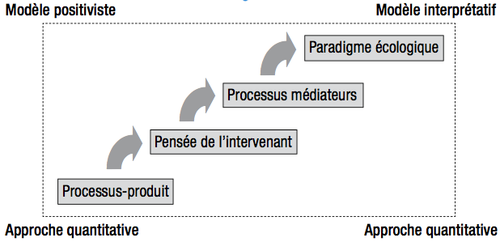

Figure 1. Evolution of the process of analysis (Carreiro da Costa, 2008).

