Juan Sandoval, Pierre Vieyres and Gérard Poisson
University of Orléans, PRISME Laboratory, Bourges, France
{juan.sandoval-arevalo, pierre.vieyres, gerard.poisson}@univ-orleans.fr

Generalized Framework for Control of Redundant Manipulators in RA-MIS
Abstract— In this paper, we provide a generalized framework for the dynamic control of redundant manipulators applied to robot-assisted minimally invasive surgeries (RA-MIS), dealing simultaneously with kinematic constraints, surgical tool trajectory and collisions in the robot’s body. During a RA-MIS, a robot inserts a surgical tool into the patient’s body through an incision point, known as the trocar point. A kinematic constraint is then generated since the tool axis must always pass through the trocar point, i.e. Remote Center of Motion (RCM) constraint, while the tool tip executes the surgical task. When a serial manipulator is used, the RCM constraint must be guaranteed by the control system. Moreover, during the event of desired or unexpected collisions between the robot’s body and its environment, e.g. medical staff or operating room equipment, during the surgical procedure, we propose a joint compliance strategy to preserve the surgical task, by exploiting the robot Jacobian null-space. Simulations were conducted to validate the effectiveness of the proposed formulation, using a Kuka LBR 7 iiwa R800 robot arm.

Keywords: Robot-Assisted Minimally Invasive Surgery, torque-control, redundancy resolution, RCM constraint

INTRODUCTION
In robot-assisted Minimally Invasive Surgery (RA-MIS), a surgeon teleoperates a robot inserting surgical tools into the patient’s body through some small openings known as trocar. Besides the benefits given by the MIS compared to classical open surgery [1], e.g. reduction in recovery time, low risk of infection or minimization of scars, the robot-assisted system increases the workspace of the surgeon, usually considerably constrained in classical MIS and permits to cancel his trembling and to enhance accuracy, among other advantages.
During a RA-MIS, the robot tool tip performs a task inside the patient’s body. Simultaneously, the tool movement is constrained by the incision point, i.e. trocar point, where the contact forces at the trocar must be minimized, in order to avoid injury to the patient. The kinematic constraint provoked by the incision point is commonly known as Remote Center of Motion (RCM) constraint. Several “RCM mechanisms” have been designed to mechanically fix a RCM point and then calibrate it with the trocar [2, 3]. Moreover, commercialized robot-assisted MIS, such as the Da Vinci robotic system, for instance, use a RCM mechanism [4]. In the case of programmable RCM applied to manipulators, i.e. the RCM constraint is guaranteed by software, Aghakhani et al. provided a general kinematic characterization of the RCM constraint for MIS [5]. Hyo-Jeong and Byung-Ju [6] proposed to minimize the constraint force at the RCM by considering the manipulator as a closed chain; however, a non-redundancy property of the manipulator is required. Michelin et al. [9] proposed the application of the conventional operational space formulation, proposed by Khatib [7, 8], by choosing the objective function such as the square of the distance between the insertion position and the surgical tool. Additionally, a trajectory-following control is applied to the end-effector’s motion. In a previous study, we improved the null-motion performance of the control system proposed in [9], by implementing an extended-based formulation with null-motion feedback [10].
Moreover, null-space of the robot’s Jacobian can be exploited to perform other important tasks for a given application. If we consider that the robot shares its workspace with the medical staff and the operating room equipments, collisions in the robot’s body may occur during the surgical procedure, degrading the performance of the surgical task. An advantage of using lightweight torque-controlled robots in this context is the feasibility to implement compliant control strategies [11] dealing with the collisions and preserving as best as possible the surgical task objectives.
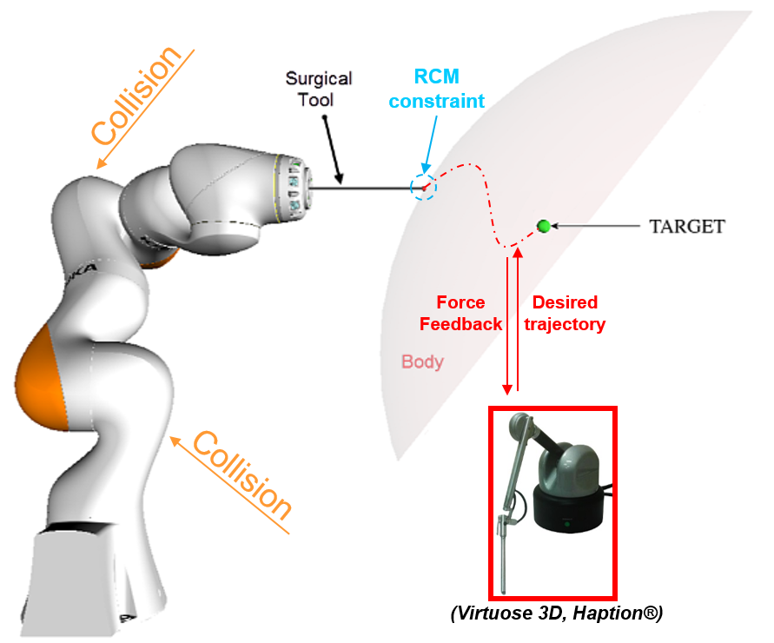
Figure 1. Representation of a complete tele-operated serial robot-assisted MIS system. The robot tool tip is tele-operated to perform a surgical task, while a RCM constraint is guaranteed at the point of incision.
In this paper, a generalized torque-control framework for RA-MIS is proposed, in order to simultaneously perform the surgical task, guaranteeing the RCM constraint and dealing collisions with the robot’s body. A strict hierarchy redundancy resolution method is applied [12], in order to define the priority order of these different tasks.
The paper is organized as follows. Section II presents the generalized framework proposed and the definition of each task is detailed. Section III reports simulation results using the dynamic model of a Kuka LBR 7 iiwa R800 robot arm. The last section is devoted to conclusions of the proposed control approach.

Generalized Torque-Control Framework

Control Approach – Strict Priority
The dynamic model of a $n$-DOF serial manipulator can be written in joint-space coordinates as follows:
$M\left(q\right)\ddot{q}+C\left(q,\dot{q}\right)\dot{q}+g\left(q\right)-τ_{ext}=τ_{c}$ (1)
where $M\left(q\right) ∈ R^{n×n}$ represents the inertia matrix, $C\left(q,\dot{q}\right)\dot{q} ∈ R^{n}$ is the generalized centrifugal and Coriolis forces,$g(q) ∈ R^{n}$ is the generalized gravitational forces, $τ_{c}$ and $τ_{ext} ∈ R^{n}$ are the generalized control and external torques, respectively, and $q ∈ R^{n}$ is a vector of generalized joint coordinates.
A potential definition for the control torque$τ_{c}∈ R^{n}$ with compensation of dynamics effects, i.e.$\hat{C}\left(q,\dot{q}\right), \hat{g}\left(q\right)$, is given by:
$τ_{c}=τ+\hat{C}\left(q,\dot{q}\right)\dot{q}+\hat{g}\left(q\right)$ (2)
where $τ∈ R^{n}$represents a set of $r$ number of control torque tasks$τ_{1}$,$τ_{2}$, …,$τ_{r}$ organized hierarchically, e.g. $τ_{1}$ is higher priority than $τ_{2}$ and so on, and defined as follows:
$τ=τ_{1}+\sum_{i=2}^{r}{N_{i}(q)τ_{i}}=J_{1}^{T}F_{1}+\sum_{i=2}^{r}{N_{i}(q)J_{i}^{T}F_{i}}$ (3)
The null-space projection guarantees that a task is not perturbed by another lower priority task. The null-space projector $N_{i}$ is defined by”
$N_{i}\left(q\right)=I-{J_{i-1}^{A}(q)}^{T}{\left({J_{i-1}^{A}(q)}^{+}\right)}^{T}$ (4)
where ${J_{i-1}^{A}(q)}^{+}$ is the inertial-weighted pseudo-inverse [7] of $J_{i-1}^{A}\left(q\right)$. The augmented Jacobian matrix $J_{i-1}^{A}\left(q\right)$ can be defined as follows:
$J_{i-1}^{A}\left(q\right)=\left[\begin{matrix}\begin{matrix}J_{1}(q) \\ J_{2}(q)\end{matrix} \\ ⋮ \\ J_{i-1}(q)\end{matrix}\right]$ (5)
As mentioned before, in the context of the RA-MIS using a torque-controlled redundant manipulator, the strict hierarchy in (3) can be used to implement some important tasks. Figure 1 shows a general case of robot-assisted MIS, where the desired trajectory of the tool tip is controlled by the operator thanks a haptic device. Simultaneously, the control system must guarantee the passage of the tool through the trocar point. Moreover, the use of a lightweight torque-controlled robot allows to implement compliance control strategies, useful in the case of desired or unexpected collisions with the robot’s body. In the following, we study in detail the implementation of the three tasks. In our case, $J_{1}\left(q\right)∈ R^{m×n}$ corresponds to the Jacobian matrix mapping the joint velocity $\dot{q}$ to the Cartesian velocity $\dot{x}∈ R^{m}$of the tool tip, i.e. $m=3$, whereas $J_{2}\left(q\right)=J_{RCM}(q)$ is the Jacobian matrix relative mapping the joint and the RCM constraint coordinates.

Cartesian Impedance Control
The control torque$τ_{1}$ performing the tool tip trajectory is given by:
$τ_{1}=J_{1}^{T}\left[K_{C}\left(x_{d}-x\right)+D_{C}\left({\dot{x}}_{d}-\dot{x}\right)\right]$ (6)
where $x_{d}(t)∈ R^{m}$ is the desired tool tip trajectory. For instance, in a tele-operated system $x_{d}(t)$ is sent from the master station operated by the surgeon. Moreover, Eq. (6) implements a Cartesian impedance control regulated by the gains $K_{C}$ and$D_{C}$, as implemented in [11].
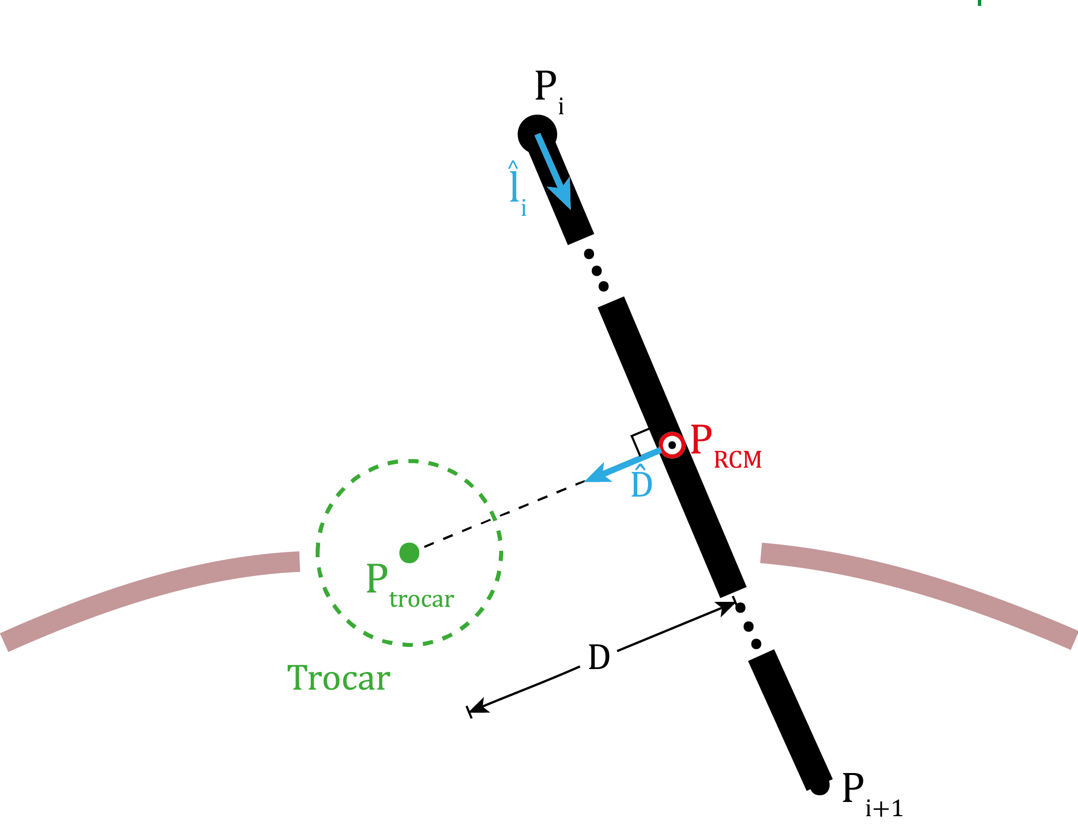
Figure 2. Geometrical description of the RCM constraint where the minimization of the distance $D$ must be achieved

Remote Center of Motion Constraint
Control torque $τ_{2}$ corresponding to the second priority-level task guaranteeing the RCM constraint, can be written as:
$τ_{2}=N_{2}J_{RCM}^{T}\left[K_{R}\left(t_{d}-t\right)+D_{R}\left({\dot{t}}_{d}-\dot{t}\right)\right]$ (7)
where the task $t∈ R^{1}$ corresponds to the minimal distance $D$ between the trocar point and the surgical tool (Fig. 2). Therefore, in order to guarantee the RCM constraint, the desired task value is set as$t_{d}=0 and {\dot{t}}_{d}=0$. The detailed method to define the Jacobian matrix $J_{RCM}(q)∈R^{1×n}$ can be found in [13]. Similar to Eq. (7), the force${ F}_{2}$ is used to apply impedance control at the RCM space, regulated by the gains $K_{R}$ and$D_{R}$, as implemented in [11].

Joint Compliance Control
A third priority-level task will be applied, consisting in the implementation of a joint compliance control allowing to deal with collisions with the robot’s body, as follows:
$τ_{3}=N_{3}\left(K_{J}\left(q_{d}-q\right)-D_{J}\dot{q}\right)$ (8)
where, $q_{d}$ is a desired robot joint configuration and $D_{j}=d_{j}\hat{M}$ stabilizes the internal motion, as suggested in [7]. The stiffness gain $K_{J}$ implements a compliance when collision occurs. Once the contact disappears, the desired joint configuration is recovered.

Simulation Results
In order to validate the control framework proposed in this paper, the dynamic model of the Kuka LBR 7 iiwa R800 robot arm was used. This robot is a redundant torque-controlled one with $7$ rotational joints. In the proposed study (Fig. 3), the robot holds a surgical tool at the end effector and inserts it through a trocar, with position $P_{trocar}=\left[0,0.5,0.1\right]$m. The desired tool tip trajectory is defined between the incision point and a target point $Target=\left[0,0.55,0.05\right]$m.
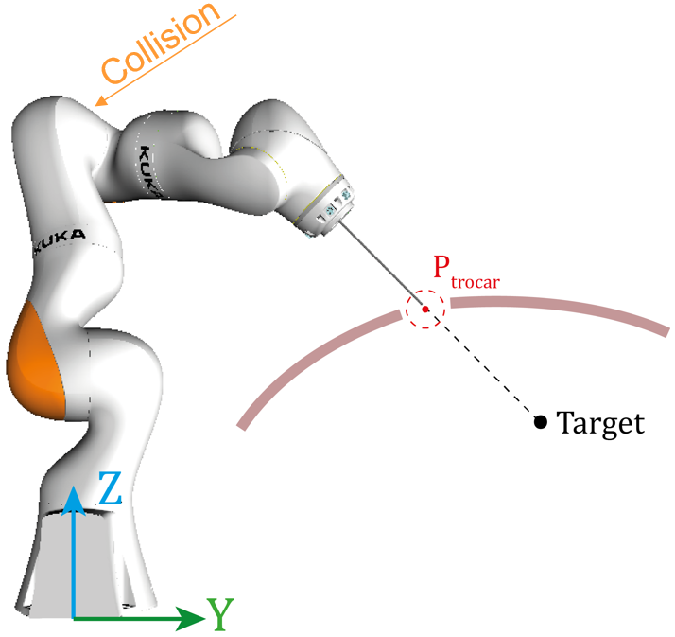
Figure 4. Study case using dynamic model of the Kuka LBR 7 iiwa R800 robot arm. A desired linear trajectory is given to the tool tip while guaranteeing the RCM constraint. Moreover, a collision occurs with joint 3 between $time=3$ s and $time=4$ s
The desired impedance parameters were adjusted as follows: $K_{C}=diag\left[700,700,700\right]$ N/m, $D_{C}=diag\left[70,70,70\right]$ Ns/m, $K_{R}=500$ N/m, $D_{R}=50$ Ns/m, $K_{j}=diag\left[100,100,100,100,100,100,100\right]$ Nm/rad and $d_{j}=30$ s⁻¹, respectively. During the time interval chosen between 3 s and 4 s, a collision occurs between the third link and a compliant environment of stiffness value $k_{e}=30$ Nm/rad. Before the collision, the joint desired configuration for the compliance task is set to$q_{d}=q$ until 2.7 s when a stabilized joint configuration is achieved, and the vector is then set to$q_{d}=q(at 2.7 s)$, activating the stiffness effect of the joint compliance task and allowing to preserve as best as possible the surgical task during the collision. Likewise, the initial joint configuration was set to $q\left(0\right)=\left[15.2,31.9,50.5,115.9,-127.3,49,0\right]$ deg.

The minimization of distance $D$ is shown in Fig. 5. It is evidenced that a small perturbation takes place during the collision. Nevertheless, the distance $D$ never increases more than 0.5 mm.
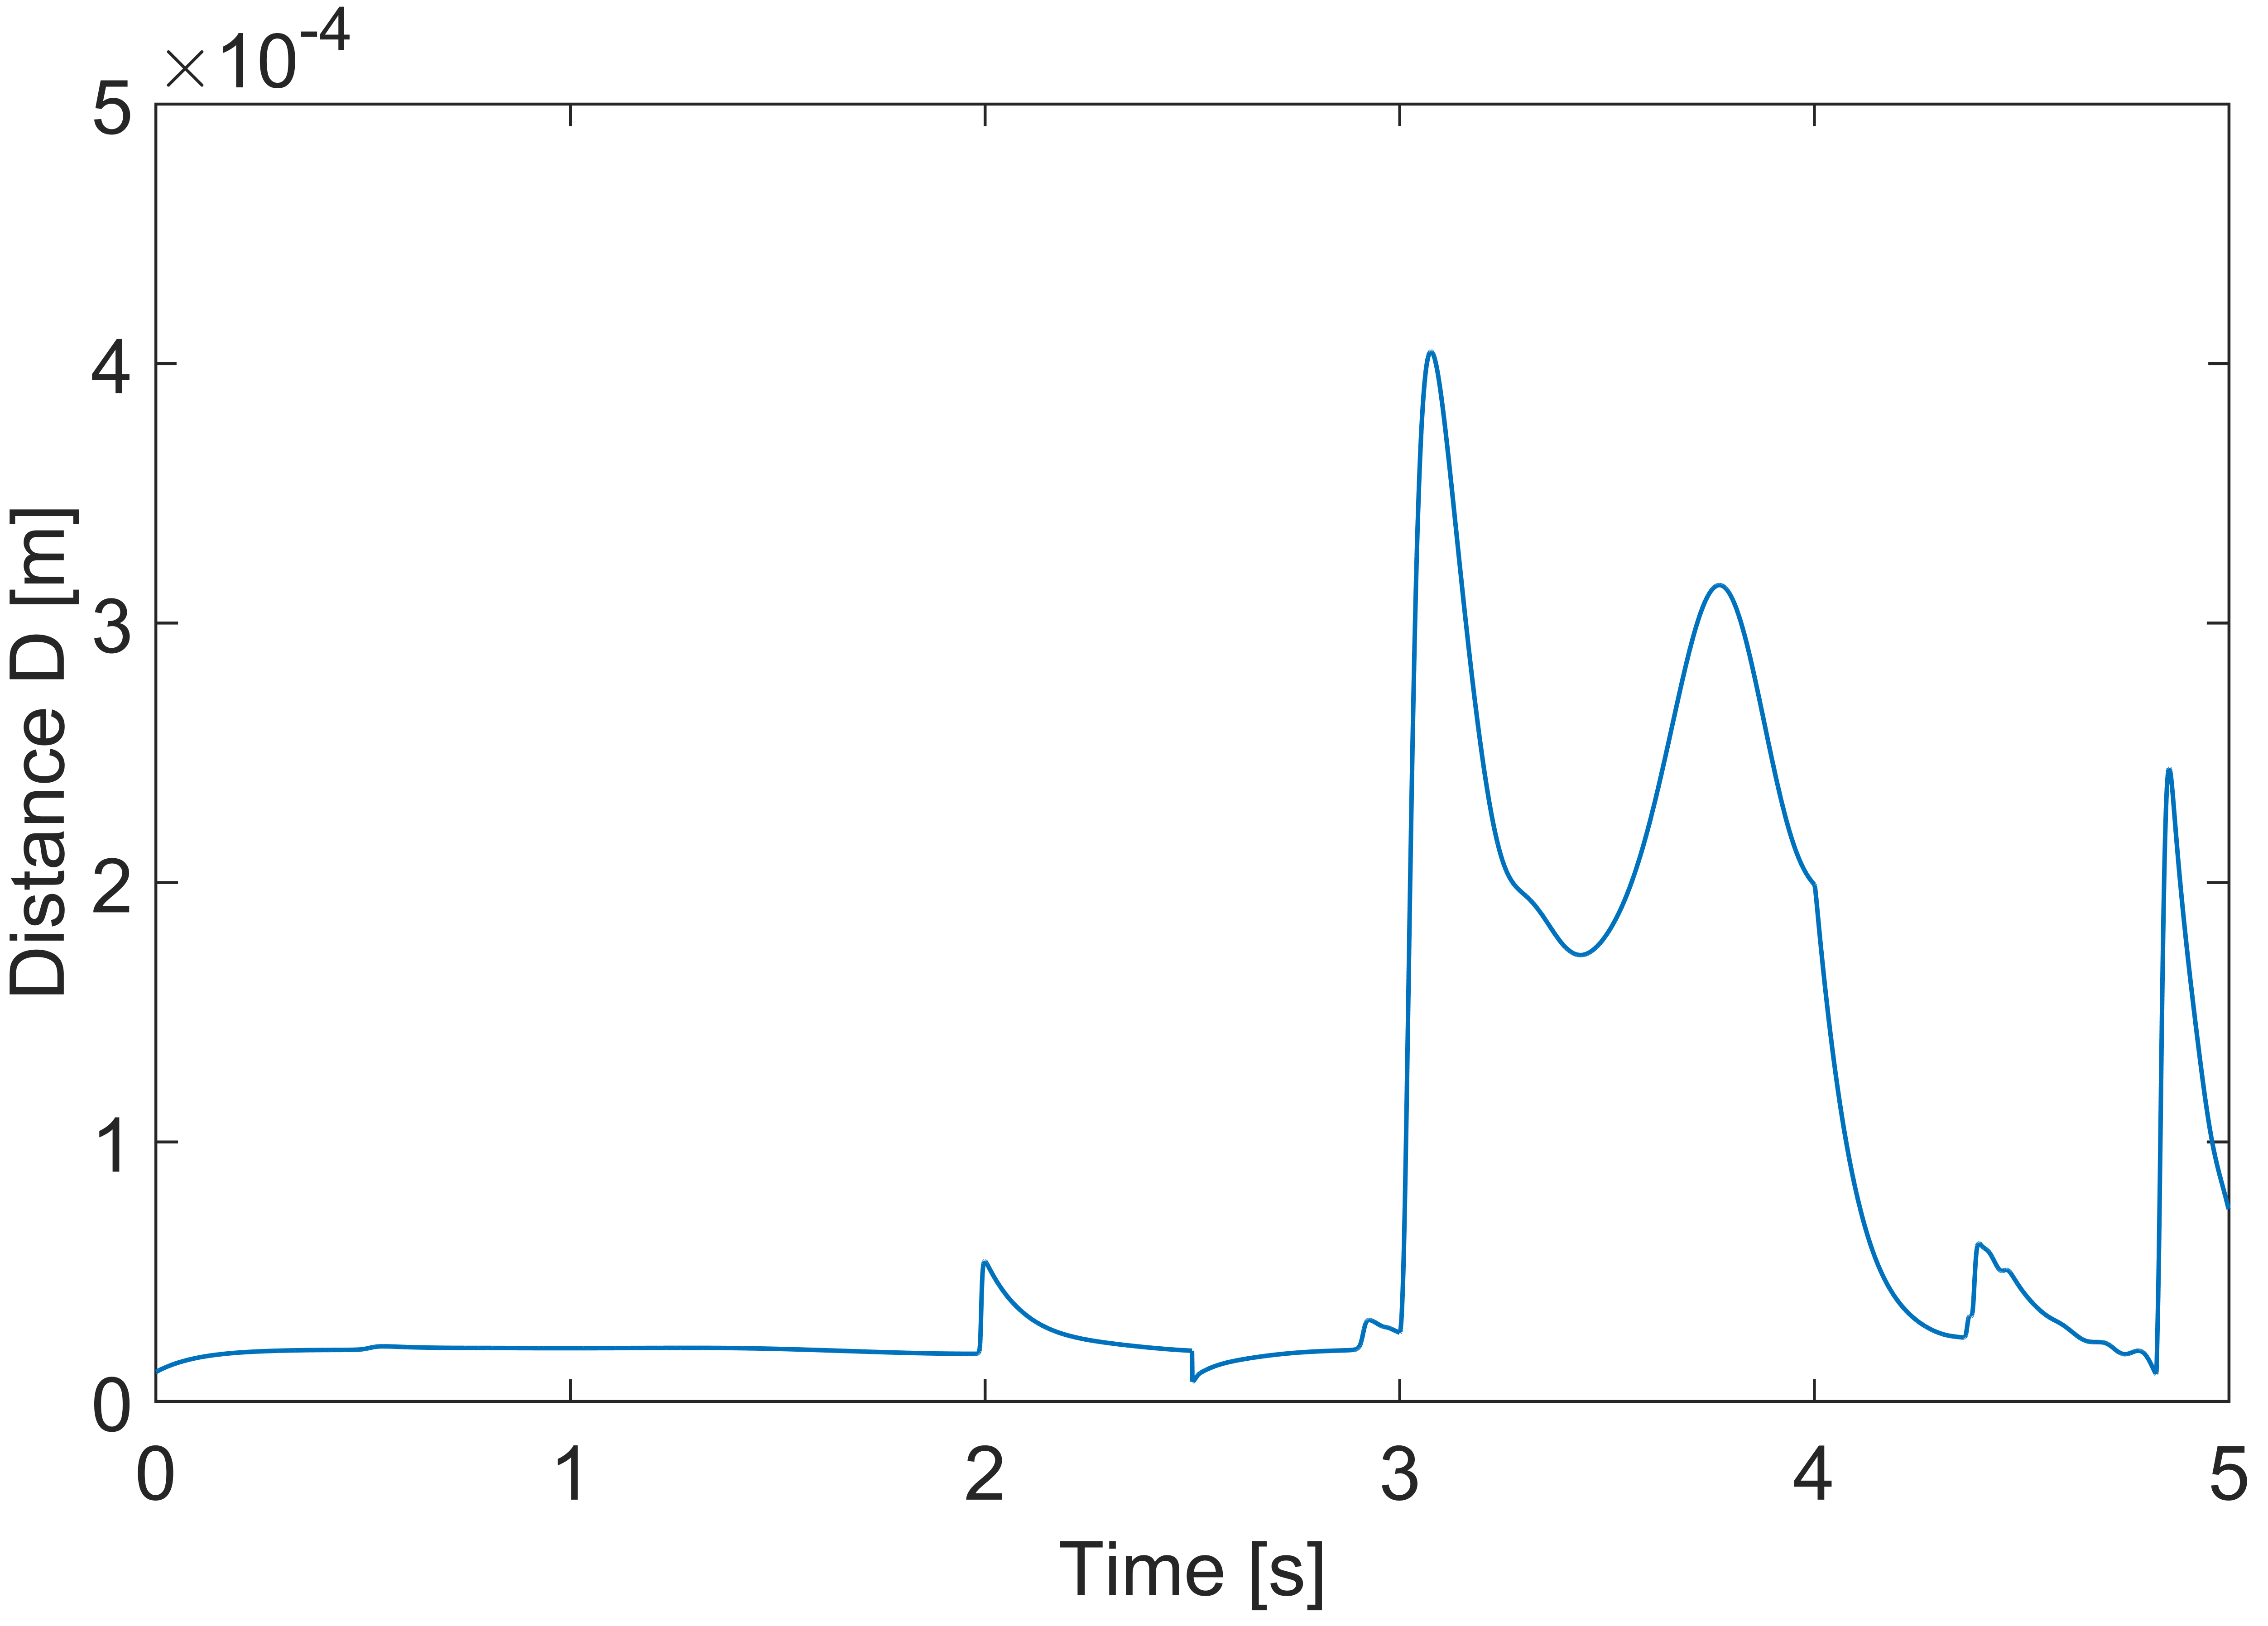
Figure 5. Minimization of the objective function $t=D$

Fig. 6 shows the tool tip trajectory, where a slight deviation of the desired trajectory can be observed during the collision, caused by the dynamic effects generated by the unknown external force applied to the robot’s body. Moreover, the joint position trajectories are presented in Fig. 7, where it is evidenced the effectiveness of the joint compliance task, permitting to reconfigure the joint position of the robot during the contact and recover the stabilized configuration after the collision.
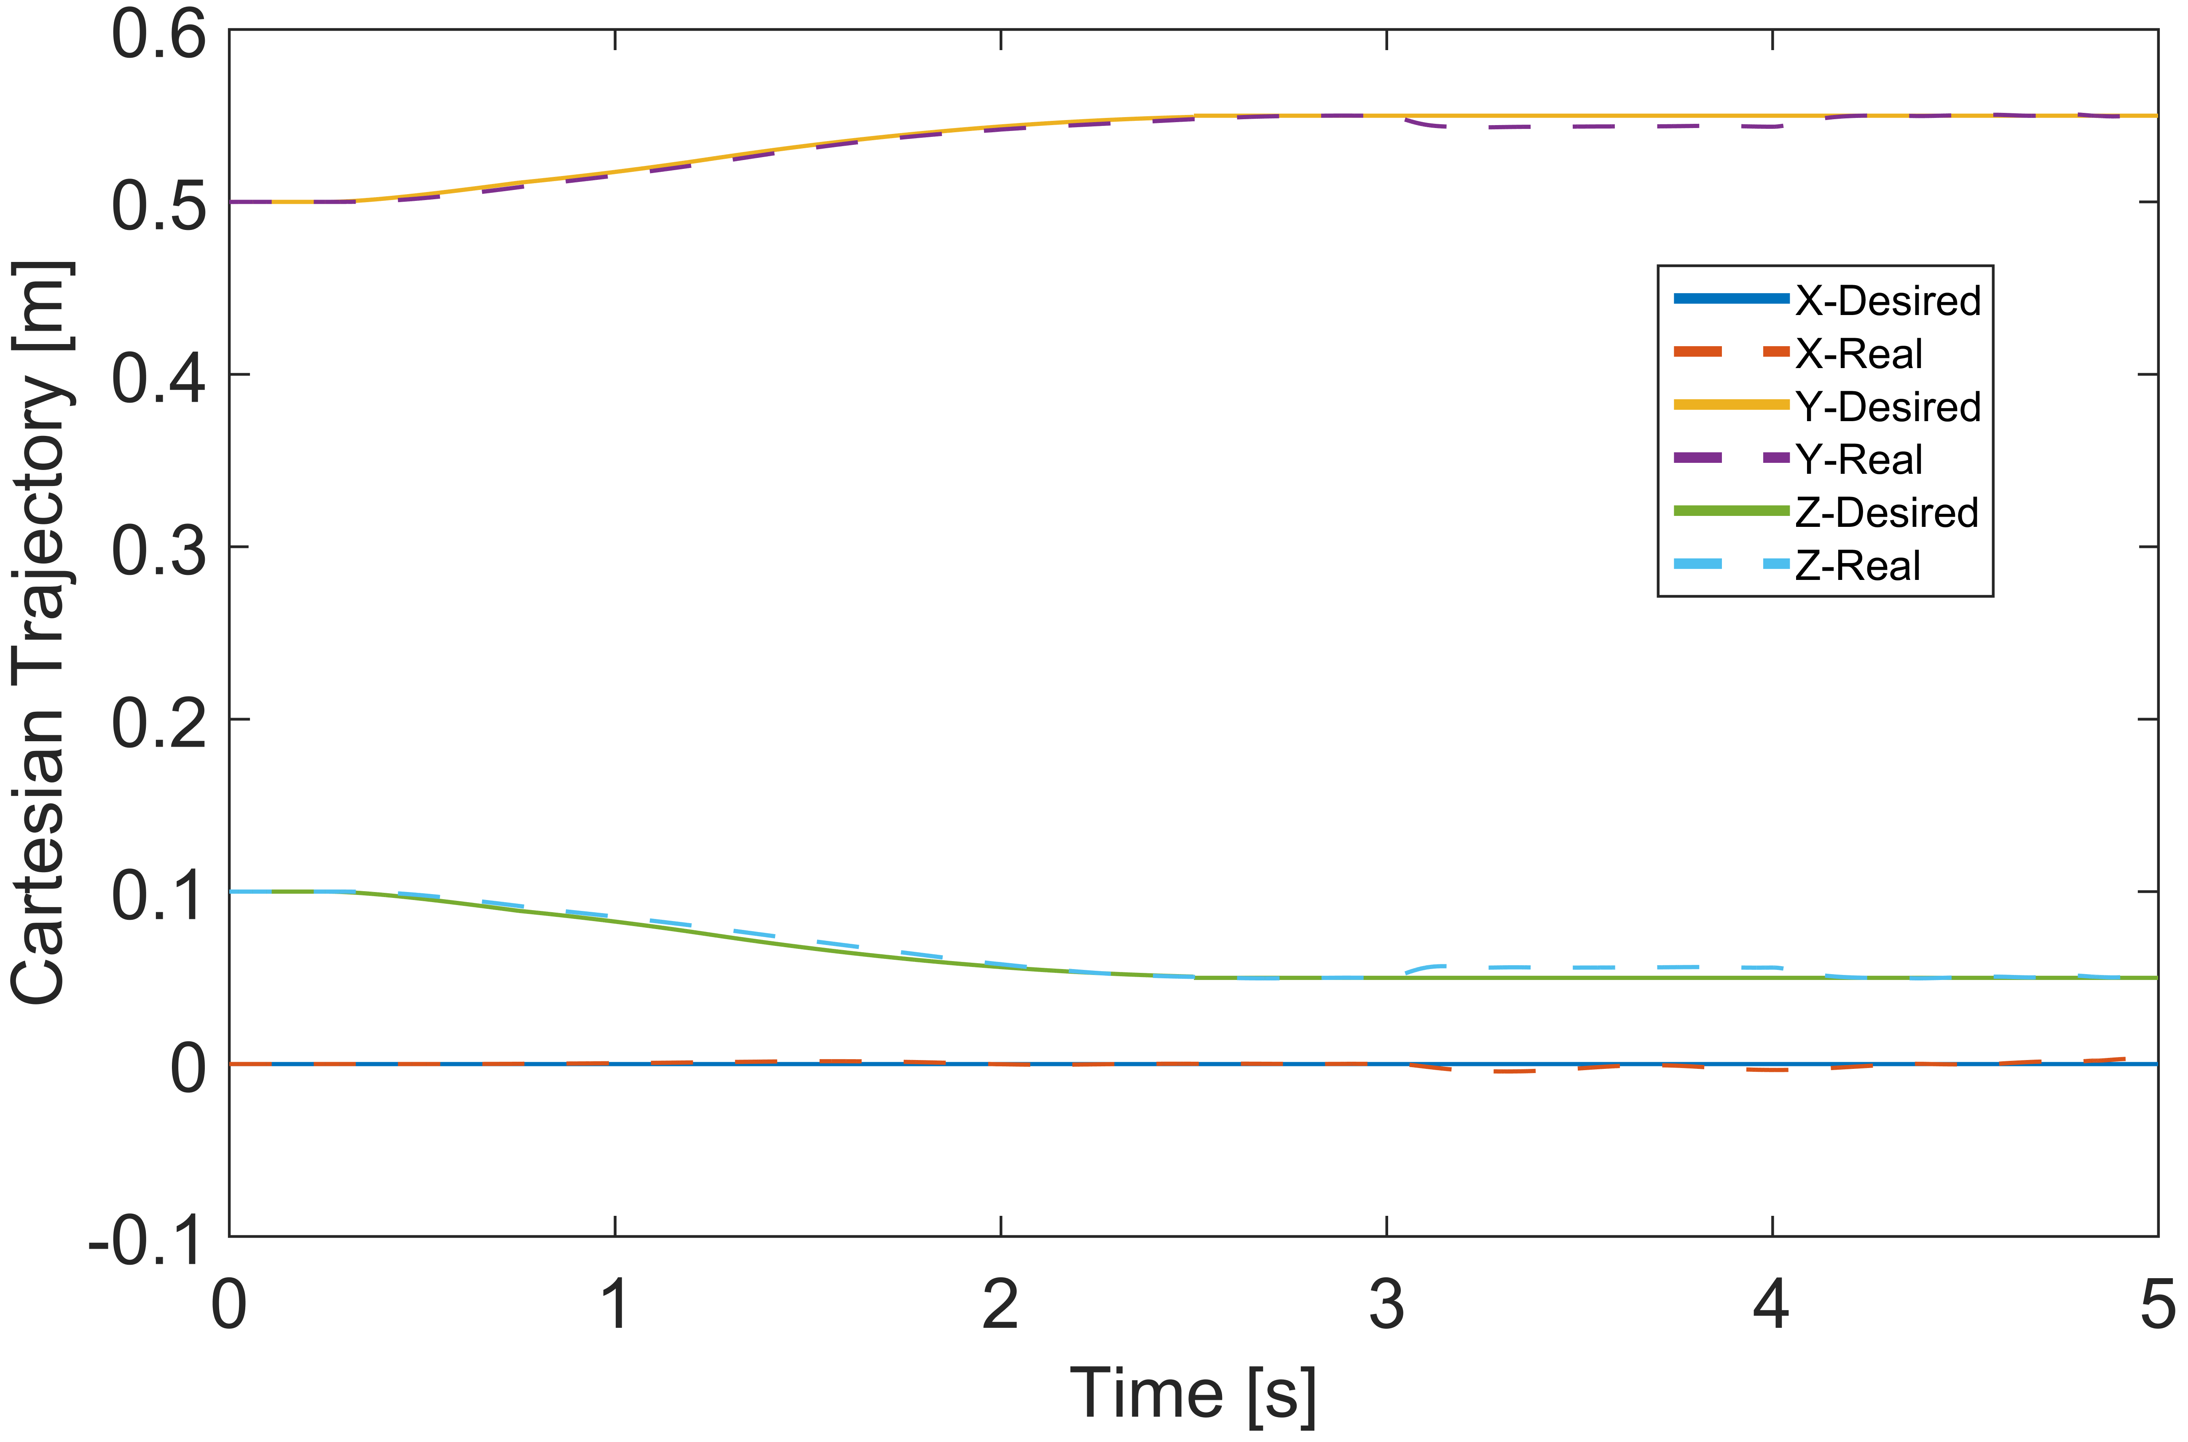
Figure 6. X, Y and Z task-space trajectories for the tool tip

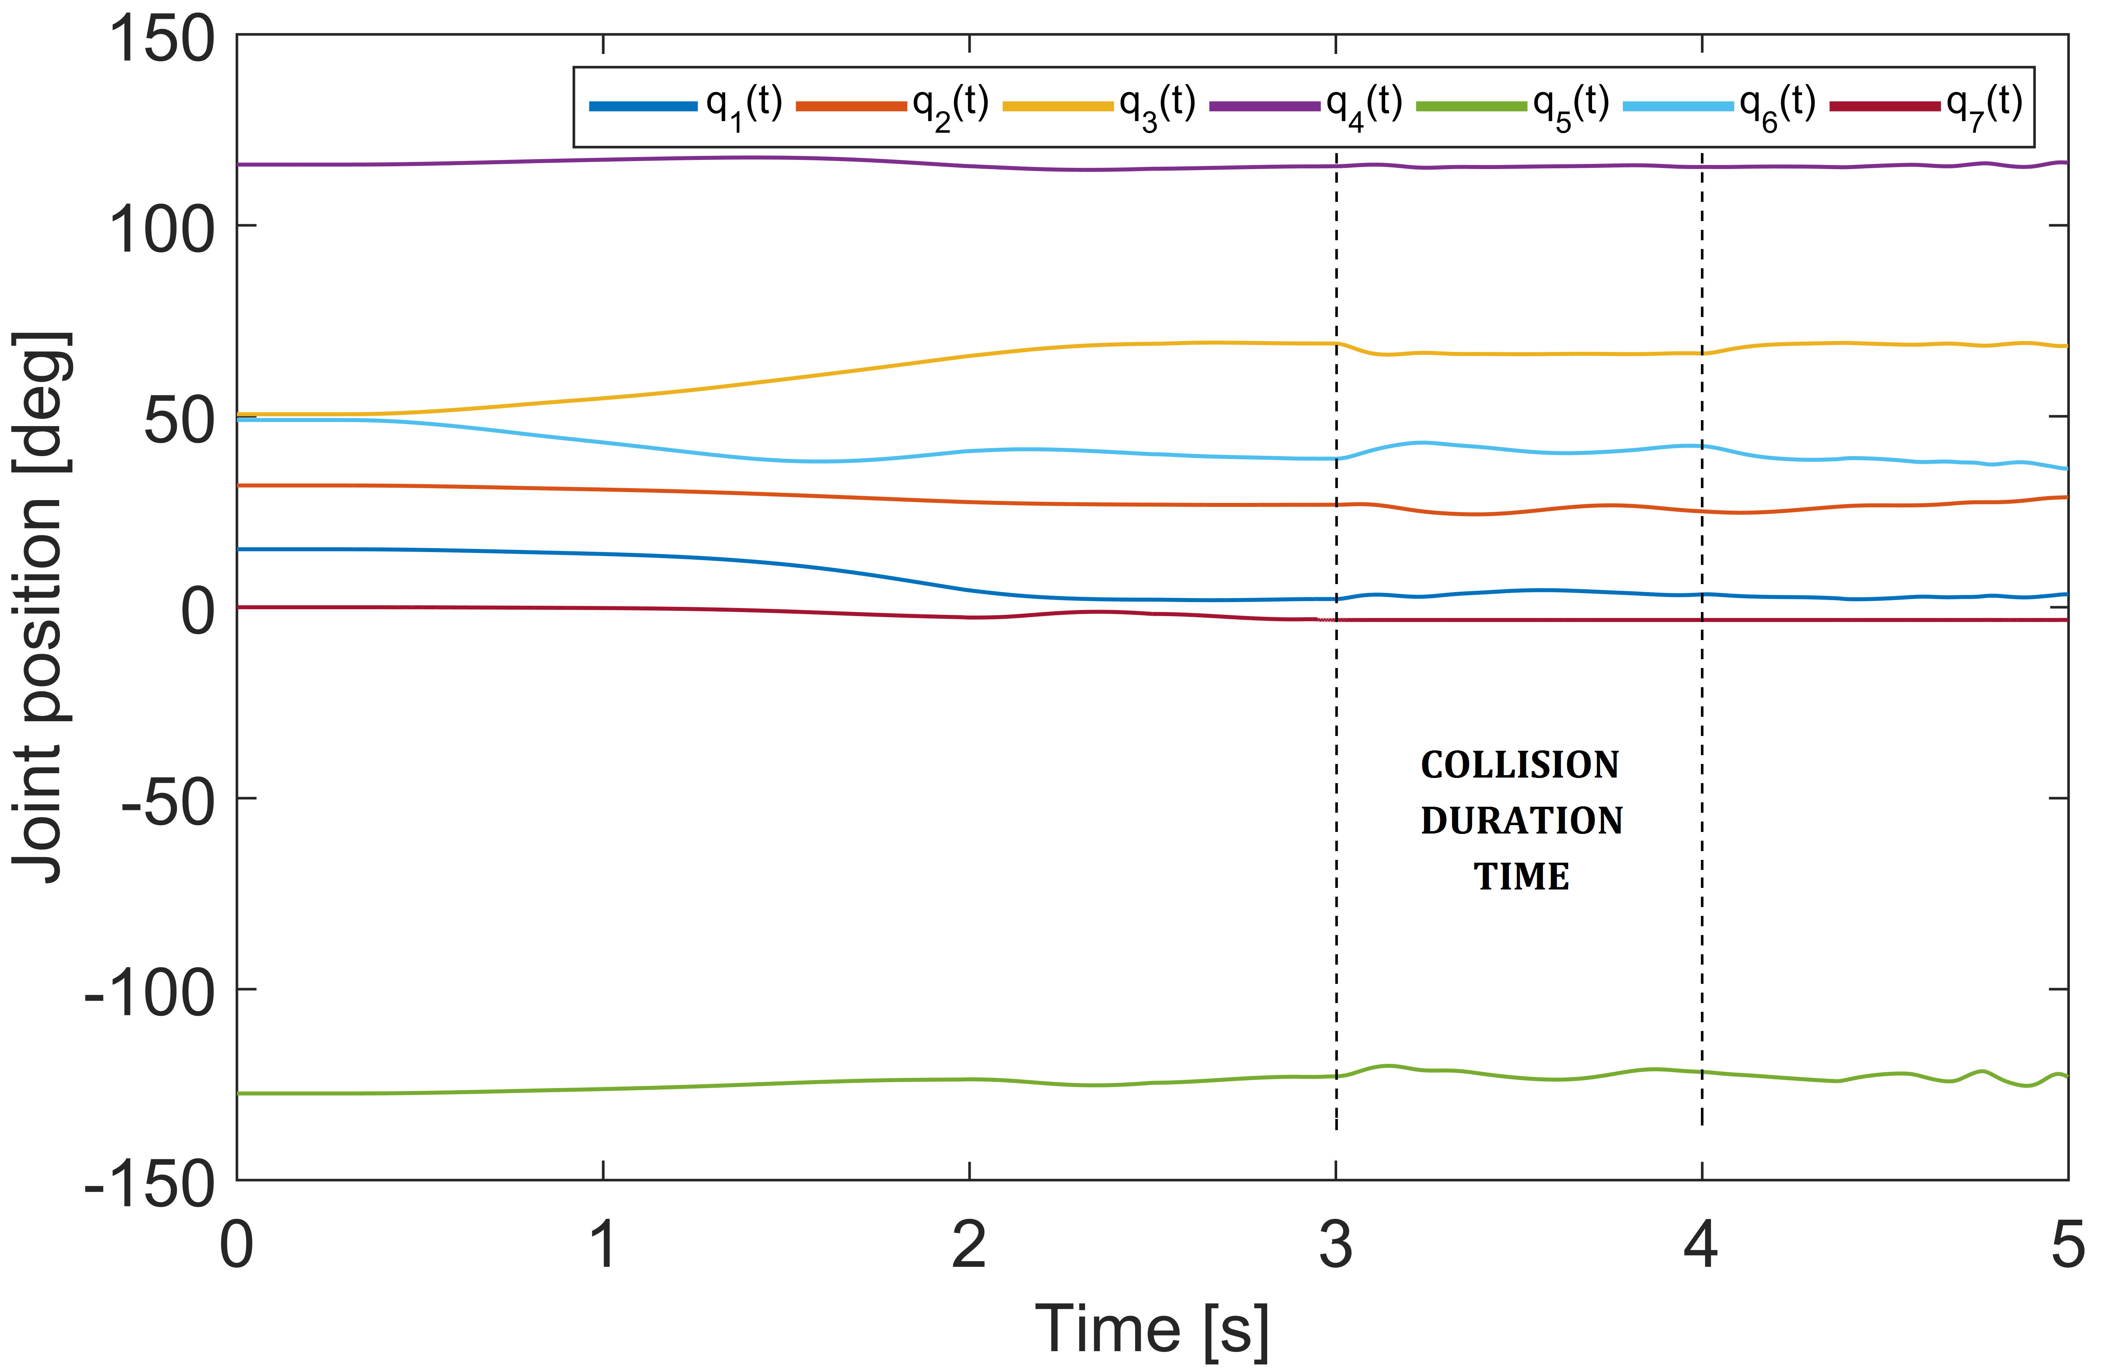
Figure 7. Joint position trajectories for the case of study presented

Conclusions
A new generalized framework for torque-controlled redundant manipulators has been applied to robot-assisted minimally invasive surgeries. The framework uses a strict priority method based on null-space projectors, allowing to simultaneously implement multiple tasks by priority order. In the case of RA-MIS, we proposed the implementation of three main tasks, concerning the RCM constraint, the tool tip trajectory and the joint compliance control in case of collisions with the robot’s body. Nevertheless, and depending of the robot redundancy degree, a non-limited number of tasks could be implemented in the generalized framework. The dynamic model of a torque-controlled robot was used to validate the effectiveness of the framework.

References

[1] H. Azimian, R. V. Patel, and M. D. Naish, "On constrained manipulation in robotics-assisted minimally invasive surgery," in Biomedical Robotics and Biomechatronics (BioRob), 2010 3rd IEEE RAS and EMBS International Conference on, 2010, pp. 650-655.
[2] C.-H. Kuo and J. Dai, "Robotics for Minimally Invasive Surgery: A Historical Review from the Perspective of Kinematics," in International Symposium on History of Machines and Mechanisms, H.-S. Yan and M. Ceccarelli, Eds., ed: Springer Netherlands, 2009, pp. 337-354.
[3] C. H. Kuo, J. S. Dai, and P. Dasgupta, "Kinematic design considerations for minimally invasive surgical robots: an overview," Int J Med Robot, vol. 8, pp. 127-45, Jun 2012.
[4] C. Freschi, V. Ferrari, F. Melfi, M. Ferrari, F. Mosca, and A. Cuschieri, "Technical review of the da Vinci surgical telemanipulator," The International Journal of Medical Robotics and Computer Assisted Surgery, vol. 9, pp. 396-406, 2013.
[5] N. Aghakhani, M. Geravand, N. Shahriari, M. Vendittelli, and G. Oriolo, "Task control with remote center of motion constraint for minimally invasive robotic surgery," in Robotics and Automation (ICRA), 2013 IEEE International Conference on, 2013, pp. 5807-5812.
[6] C. Hyo-Jeong and Y. Byung-Ju, "Modeling of a constraint force at RCM point in a needle insertion task," in Mechatronics and Automation (ICMA), 2011 International Conference on, 2011, pp. 2177-2182.
[7] O. Khatib, "A unified approach for motion and force control of robot manipulators: The operational space formulation," Robotics and Automation, IEEE Journal of, vol. 3, pp. 43-53, 1987.
[8] O. Khatib, "Motion/force redundancy of manipulators," in Japan—USA Symposium on Flexible Automation, Kyoto, Japan, July, 1990, pp. 337-342.
[9] M. Michelin, P. Poignet, and E. Dombre, "Dynamic task/posture decoupling for minimally invasive surgery motions: simulation results," in Intelligent Robots and Systems, 2004. (IROS 2004). Proceedings. 2004 IEEE/RSJ International Conference on, 2004, pp. 3625-3630 vol.4.
[10] J. Sandoval, G. Poisson, and P. Vieyres, "Improved dynamic formulation for decoupled cartesian admittance control and RCM constraint," in 2016 IEEE International Conference on Robotics and Automation (ICRA), 2016, pp. 1124-1129.
[11] A. Dietrich, T. Wimbock, A. Albu-Schaffer, and G. Hirzinger, "Integration of reactive, torque-based self-collision avoidance into a task hierarchy," IEEE Transactions on Robotics, vol. 28, pp. 1278-1293, 2012.
[12] A. Dietrich, C. Ott, and A. Albu-Schäffer, "An overview of null space projections for redundant, torque-controlled robots," The International Journal of Robotics Research, p. 0278364914566516, 2015.
[13] J. Sandoval, G. Poisson, and P. Vieyres, "A New Kinematic Formulation of the RCM Constraint for Redundant Torque-Controlled Robots," in 2017 IEEE International Conference on Intelligent Robots and Systems (IROS), 2017, (submitted).

*Research supported by French Ministry of Research. Corresponding author: Juan Sandoval, PRISME Laboratory, University of Orléans, INSA CVL, France; juan.sandoval-arevalo@univ-orleans.fr. Gérard Poisson, PRISME Laboratory, University of Orléans, INSA CVL, France; gerard.poisson@univ-orleans.fr. Pierre Vieyres, PRISME Laboratory, University of Orléans, INSA CVL, France; pierre.vieyres@univ-orleans.fr.

