Figure S1. Population structure across the eight different breeds (Holstein and Friesian treated as separate breeds) where a darker colour represents a stronger degree of genomic relationship

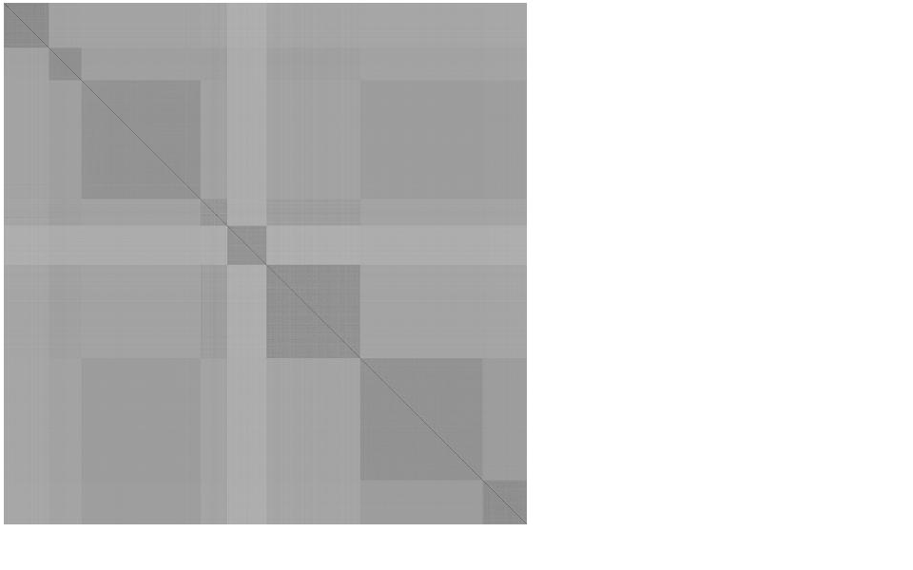

**Belgian Blue**

**Holstein-Friesian**

**Limousin**

**Hereford**

**Charolais**

**Simmental**

**Angus**

Figure S2. Genomic map of selection signatures detected by the iHS method for seven bovine breeds

F:\macro电脑\D\ireland\last\AAAA.tiff